Experiment-24
Aim: To write a Prolog program that suggests a suitable diet based on the user's disease.
Algorithm:
- Start.
- Define facts for diseases and their suggested diets.
- Create a rule suggest_diet/2 to retrieve the diet for a given disease.
- Ask the user to enter a disease.
- Search the database for the corresponding diet.
- Display the suggested diet if found; otherwise, display an error message.
- Stop.
Code:

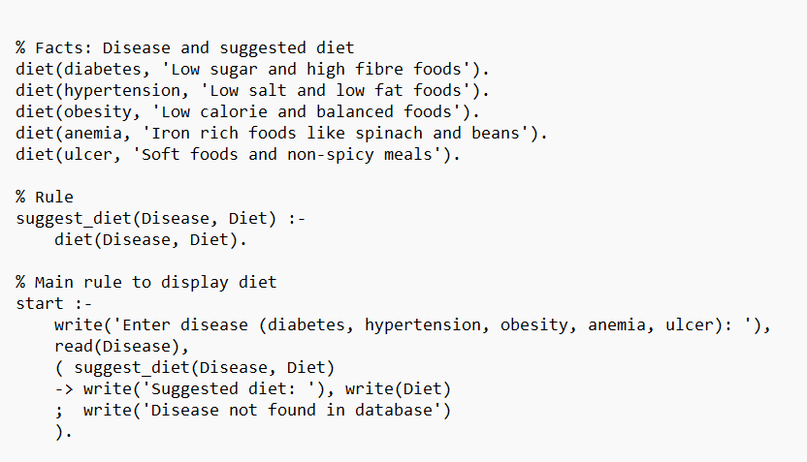
Output:
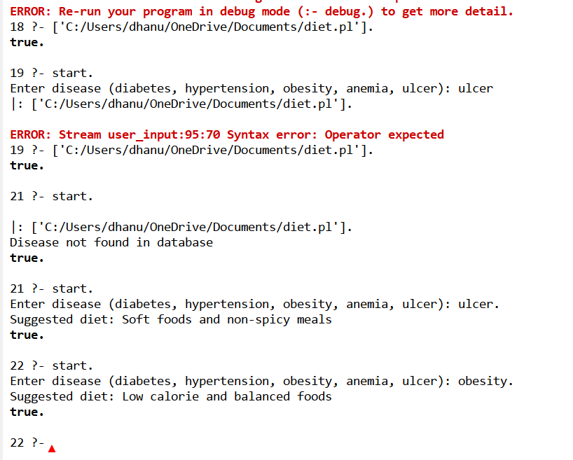
Result:
The Prolog program suggests a diet based on the disease entered by the user.

